Important things about me

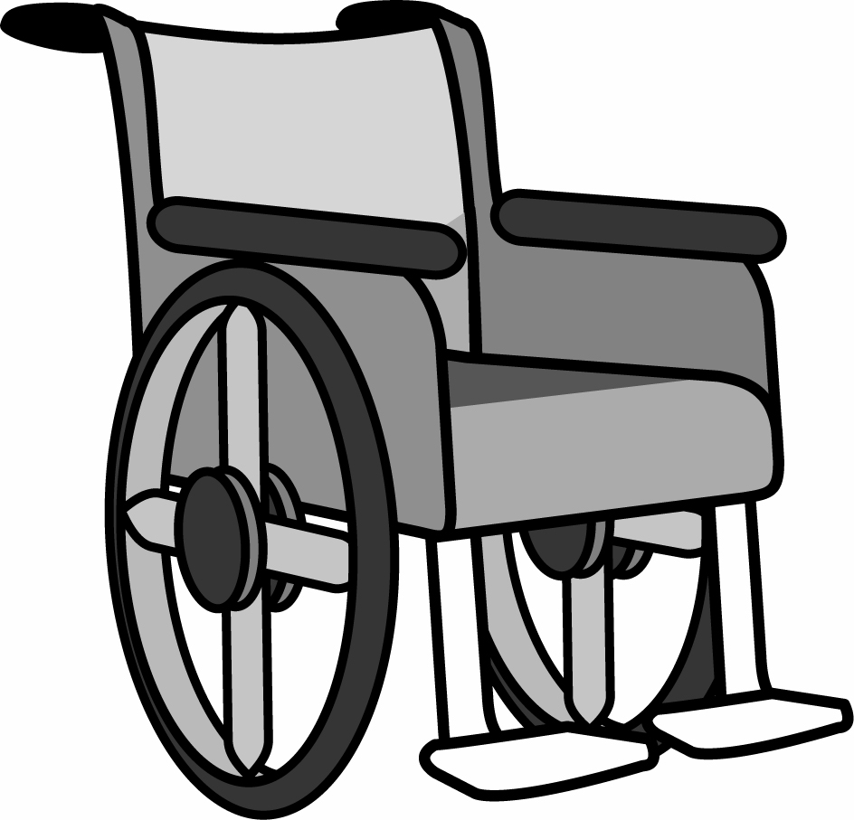

I go everywhere in my wheelchair.
I only sit my wheelchair or
my beanbag chair.

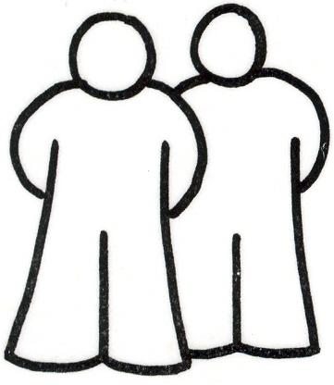
You must use a hoist to transfer me and
there must be 2 people to do this.

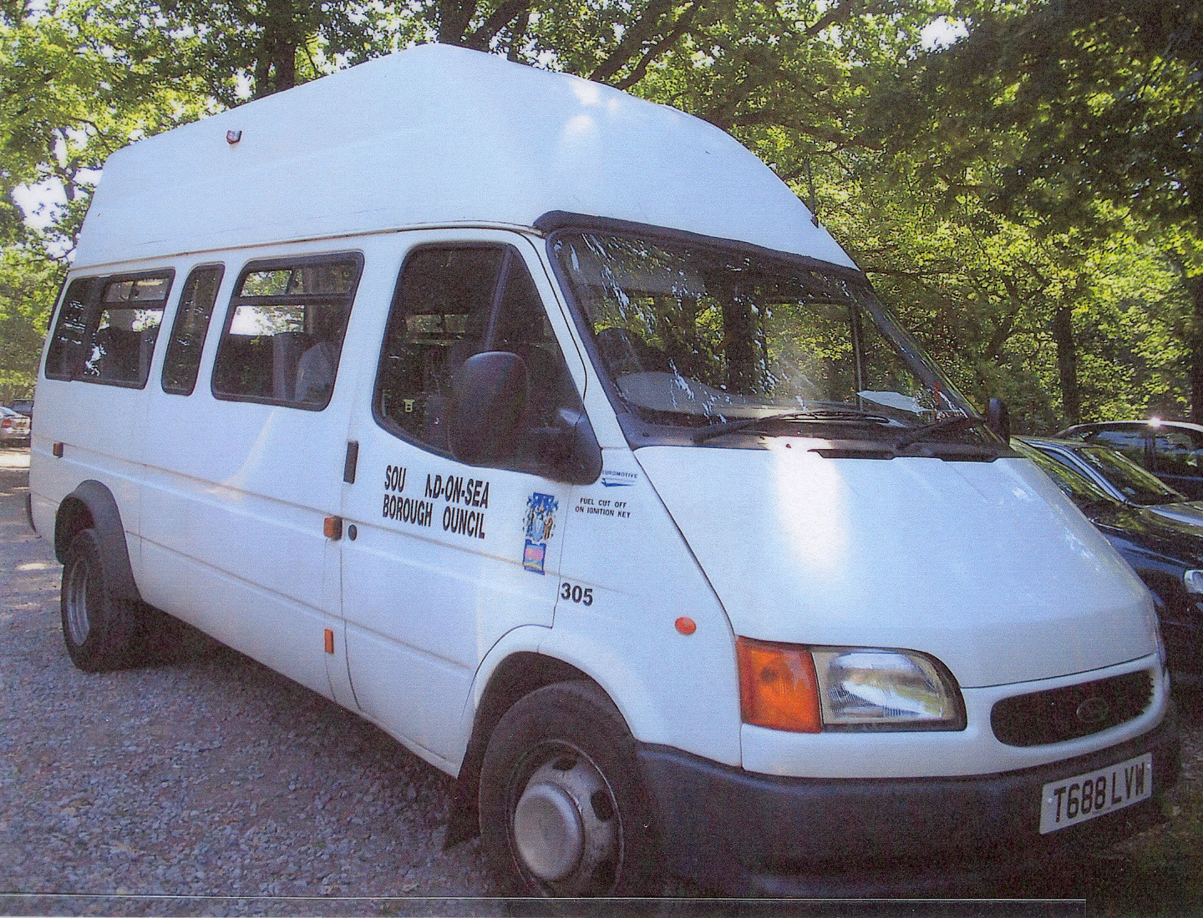
When I go on the bus, I must be in my
wheelchair with a head support

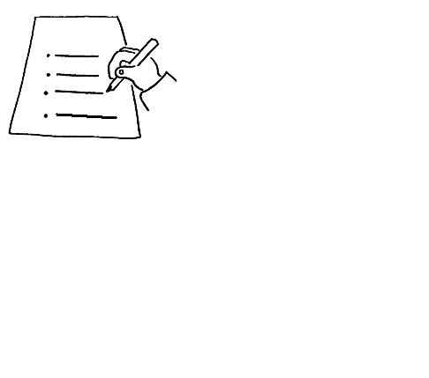
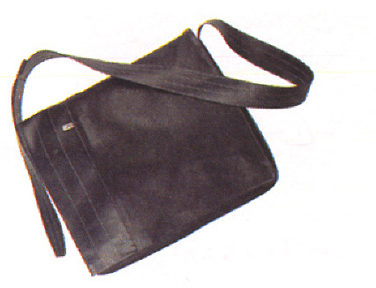
There is a list of telephone numbers and
medication in my bag.

